ARKTALAS Hoavva Project Meeting 1 (PM-1)
5-6 February 2020
Location: Nansen Center, Thormoehlensgate 47,
Bergen, Norway

Draft Meeting agenda

Day 1 – Wednesday 5 February
09:00-09:15 Welcome, approval of agenda and logistics
09:15-09:30 Tour the Table
09:30-10:00 Words from ESA (C. Donlon/D. Fernandez)
10:00-10:30 Aims & Objectives of the Arktalas project (J.A. Johannessen)
10:30-11:00 The four ASCs: Comments around the table

11:00-11:20 Coffee and tea break

11:20-12:00 Presentation of TN-1 (J.A. Johannessen and B. Chapron)
12:00-13:00 Outline of the status of the six papers (lead authors)
13:00-14:00 Lunch

14:00-14:45 Status of AVS (ODL)
14:45-15:30 Status of ADAS (NERSC and Ifremer)
15:30-1600 Challenges, Limitations and Risks

16:00-16:20 Coffee and tea break

16:20-17:00 Overview of complementary ongoing and planned projects
17:00-17:45 Discussion and assessment of TN-1 and the six papers (all)

18:00-19:30 Welcome cocktail at Nansen Center

Day 2 - Thursday 6 February
09:00-10:00 Review of the project planning and deliverables (J.A. Johannessen)
10:00-10:30 Planning of the Scientific meeting (all)

10:30-10:50 Coffee and tea break

10:50-11:15 Review and update of project website
11:15-11:25 Project logo
11:25-11:30 Summary and Review of Action Item
11:30-12:00 Presentation of nextSIM

12:00-13:00 Lunch

13:00 Adjourn
Appendix 1: Expected Participant list

Bertrand Chapron, Ifremer (bertrand.chapron@ifremer.fr)
Fabrice Collard, OceanDataLab (dr.fab@oceandatalab.com)
Lucile Gaultier, OceanDataLab (lucile.gaultier@oceandatalab.com) tbd?
Sylvain Herlédan, OceanDataLab (sylvain.herledan@oceandatalab.com) tbd?

Johnny A. Johannessen, NERSC (Johnny.Johannessen@uib.no)
Lasse Pettersson, NERSC (lasse.pettersson@nersc.no)
Anton Korosov, NERSC (anton.korosov@nersc.no)
Igor Esau, NERSC (Igor.Ezau@nersc.no)
Roshin P. Raj, NERSC (roshin.raj@nersc.no)
Einar Olason, NERSC (Einar.Olason@nersc.no)
Tim Williams, NERSC (Timothy.Williams@nersc.no)
Cathy Downy, NERSC (Catherine.Downy@nersc.no)
Adrien Perrin, NERSC (Adrien.Perrin@nersc.no)
Mohamed Babiker (Mohamed.Babiker@nersc.no)

Craig Donlan, ESA-ESTEC (Craig.Donlon@esa.int)
Diego Fernandez, ESA-ESRIN (diego.fernandez@esa.int)

Appendix 2: Project Partners

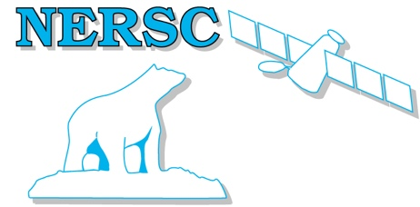 | Johnny A. Johannessen, Lasse H. Pettersson, Anton Korosov, Tim Williams, Pierre Rampal and Igor Esau  Nansen Environmental and Remote Sensing Center, Norway
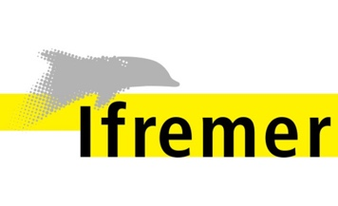 | Bertrand Chapron, Camille Lique, Fabrice Ardhuin  IFREMER, France
Fabrice Collard, Sylvain Herlédan, Lucile Gaultier
OceanDataLab, France
Eric Jeansou, Mathilde Cancet.
NOVELTIS, France

